INDIAN AGRICULTURAL CROP PRODUCTION(1997-2021)

1. INTRODUCTION:

1.1 Overview:

According to the world bank, India is a global agricultural powerhouse. One of the strong sector of the Indian economy. Around 58% population of India depends on agricultural.

Average growth rate of agricultural and allied sector in 2006-07& 2007-08 has been 4% per annum.

Agriculture is the backbone of Indian economy. Agriculture is the most important occupation for most of the Indian families.

The present cropping intensity of 137 per cent has registered an increase of only 26 per cent since 1950-51.

2018-19, 2017-18, 2011-12, 2014-15, 2013-14 respectively had maximum crop production out of all years in the records.

1.2 Purpose:

India in one of the largest producers of agriculture production in the world.

The concern about food wastage gave rise to the involvement of technology in agriculture to improve productivity and reduce wastage by proper handling of food.

The UN World food programme reports state that the primary cause of rising hunger around the global is food wastage or loss due to uneven handling of food.

Over 600 million tonnes of available biomass be converted to briquettes or other forms for minimizing the dependence on conventional energy sources.

Year wise 2014 is the year when production reached the peak production.

Correlation between area and production shows high production is directly proportional to area under cultivation.

1997-98 was the year with least production. This is potentially because of the lack of framework and mechanism to collect crop across the country.

Agricultural yield of food grains has increased by more than four times since 1950-51, and was 2,070kg/hectare in 2014-15.

1. PROBLEM DEFINITION & DESIGN THINKING:
   1. EMPATHY MAP:

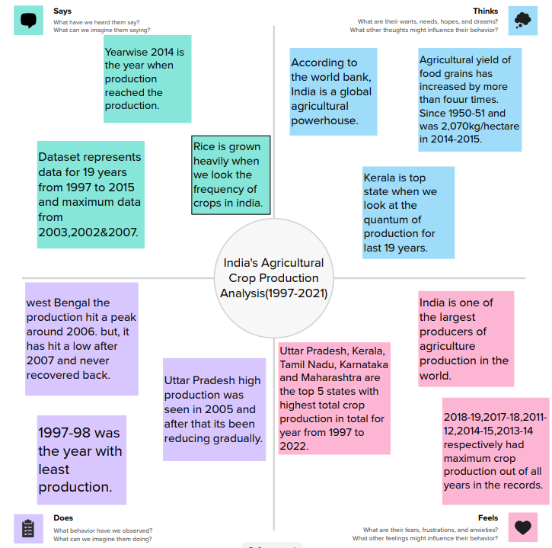2.2 INDEATION & BRAINSTORMING MAP:

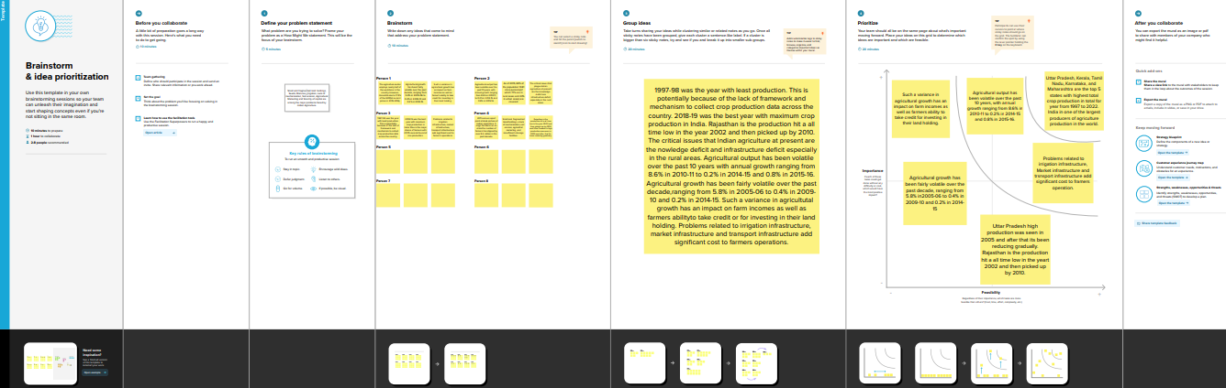

3 RESULT:

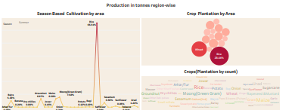

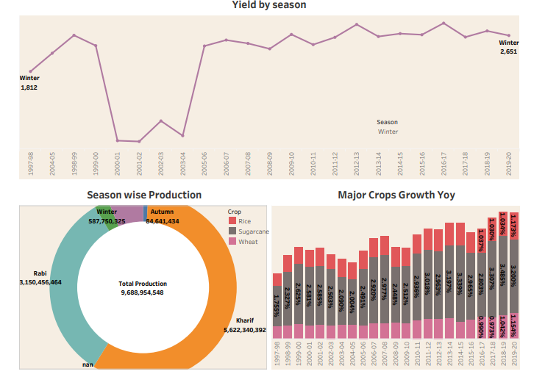

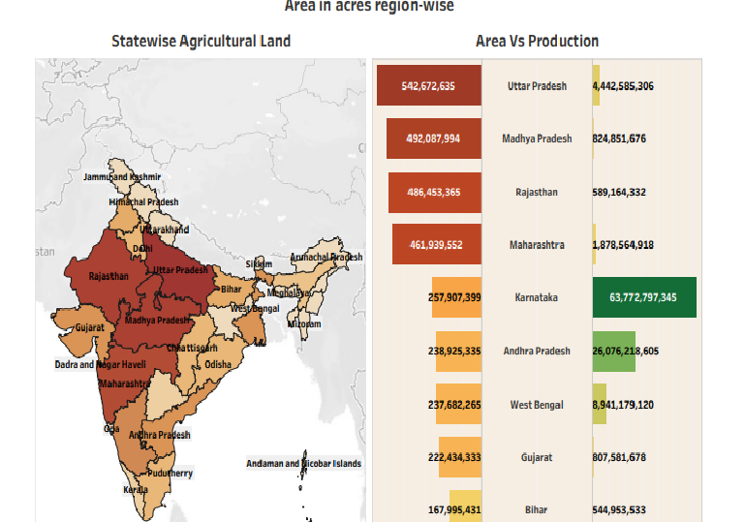

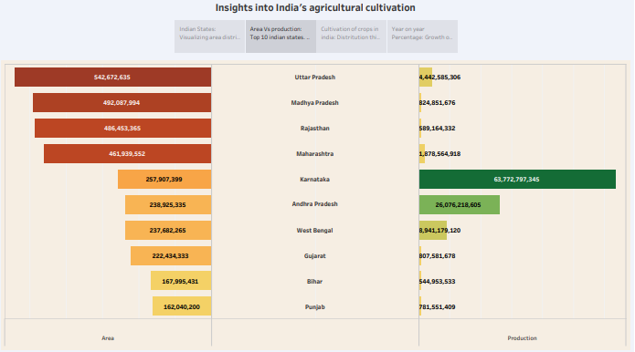

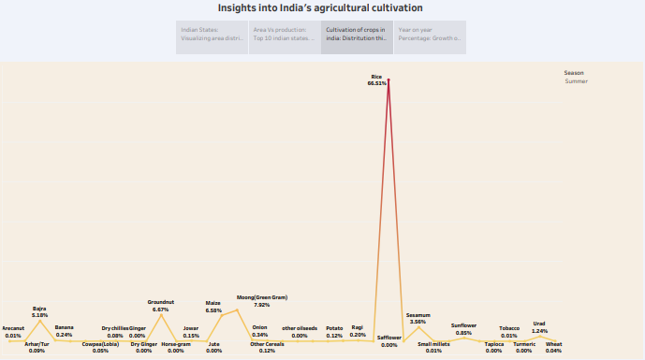

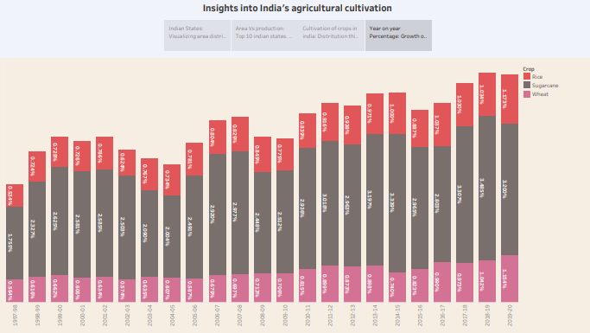

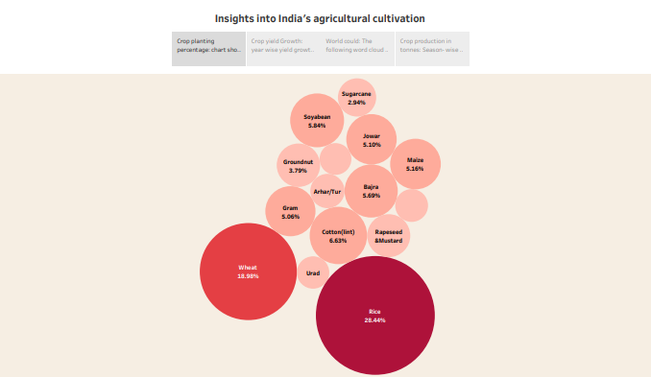

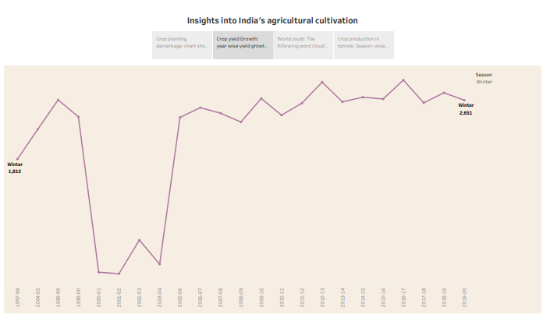

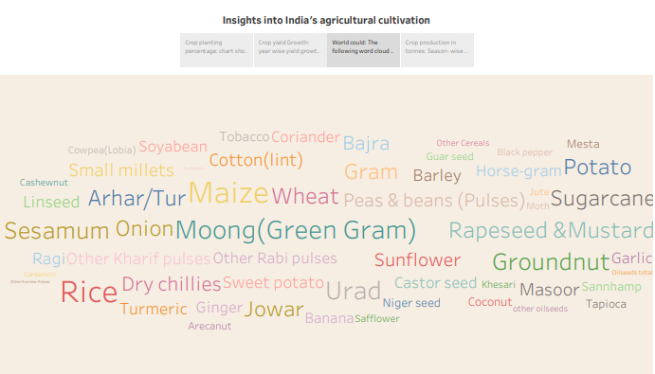

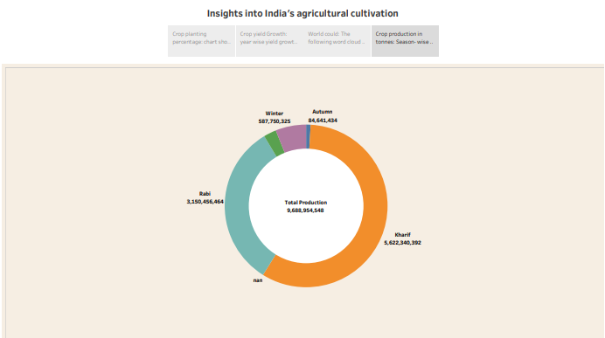

4 ADVANTAGES & DISADVANTAGES:

Advantages:

You can be your own boss.

Not a 9-5 job.

We have almost 6 months free time in a year.

We can earn as much us 5 Lpa if there is timely rainfall.

Access to quality food, quality air and we don’t experience much traffic as we experience in cities.

Disadvantages:

No fixed income.

We have to depend on the rain for agricultural production. Unexpected rains at the time of harvesting is a nightmare.

Have to work very hard physically.

You are not respected much by the fellow human beings (Not all the people but there are some people who doesn’t respect farmer’s.

If you have finished your UG or PG and still prefer to do farming, you are discouraged by the experienced farmer’s who had been farming since Decades.

5 APPLICATION:

Across the global India is the second largest country having people more than 1.3 billion.

In agriculture cultivation/production having more problems.

Uttar Pradesh is the biggest producer of crops in India.

From the above output we can see that West Bengal, Uttar Pradesh, Punjab, Andhra Pradesh and Odisha are the top 5 states with max rice production.

6 CONCLUSION:

The country has made significant progress in the adoption of cultivation and creating infrastructure for effectively and sustainably utilizing the national resources available at its command.

The critical issues that plague Indian agriculture at presentare the knowledge deficit and infrastructure deficit especially in the rural areas.

Problems related to irrigation infrastructure market infrastructure and transport infrastructure add significant cost to farmers operations.

7 FUTURE SCOPE:

Agriculture 4.0 is a considerably advanced version of precision farming methods. It had the potential to transform the existing methods of farming.

Agriculture plays a significant role in India’s growing economy. With around 54.6% of the total workforce involved in agriculture and allied sector activities, the sector contributes to 17.8% of the country gross value added (GVA).

During 2021-22, the country recorded US$ 50.2 billion in total agriculture exports with a 20% increase from US$ 41.3 billion in 2020-21.

It is projected that the Indian agriculture sector will grow by 3.5% in FY23.

8 APPENDIX:

https://www.kaggle.com

APPLICATION: